Sue Fulton - Bio

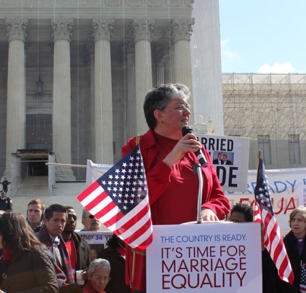

Fulton graduated West Point in 1980, in the first class to admit women. She served as a platoon leader, staff officer, and company commander in Germany before honorable discharge at the rank of Captain.  During a 25-year career in brand management at Fortune 100 companies, she gained expertise in management, cross-functional team leadership, and strategic communications. Continuing to mentor West Pointers, Fulton helped found Knights Out and OutServe, in the battle to repeal “Don’t Ask, Don’t Tell.” Fulton founded and led SPARTA to successfully end the transgender ban, while at the same time providing important (confidential) counsel to Army leaders on removing the combat exclusion role and integrating women in the combat arms.

In 2011, President Obama appointed her as the first openly gay member of the West Point Board of Visitors, and she was later elected Chair (twice) with strong bipartisan support. During 8 years on the Board, she successfully advocated for significant increases in admissions of Black, Latino, and women cadets. In 2017, she was appointed to the Board of Visitors of the National Defense University.

Since 2018, Fulton has served NJ under Governor Phil Murphy as Chief Administrator of the NJ Motor Vehicle Commission (MVC), an agency of 2,200 employees that generates ~$1.8 billion in annual revenue. During her tenure, she transformed and modernized NJ Motor Vehicles systems, shifting an in-person, stand-in-line system to a largely online transaction system, and streamlining the remaining in-person operations with queuing, SMS notifications, and scanning solutions.

In 2012, Fulton and Penny Gnesin were the first same-sex couple to wed in West Point’s Cadet Chapel. In 2019, after 24 years together, Penny died of breast cancer.

Fulton was nominated by President Biden to serve as the Assistant Secretary of for Public and Intergovernmental Affairs at the Department of Veterans Affairs, a role she served in from July 2022 to January 2024. She is currently retired.